Video Recipe (requires iPhoto & iMovie)

1. Create a smart album in iPhoto which gathers all the photos from a particular year - no censoring! (unless you have compromising pictures of someone else)
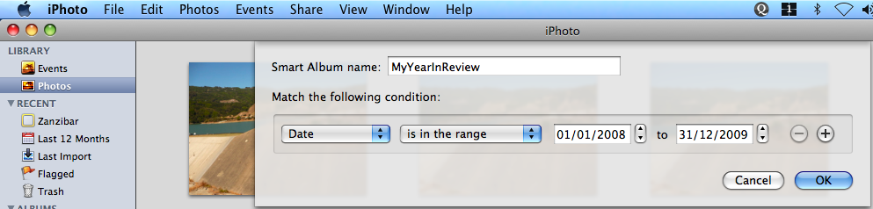
2. Create a new iMovie project, set the preferences for the project to have the photo duration be 1 second
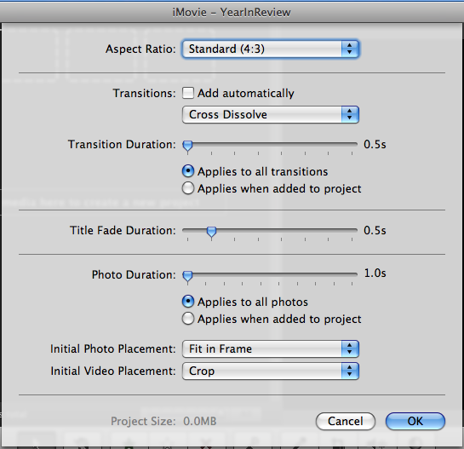
3. Drag all the photos from the album into the media/timeline
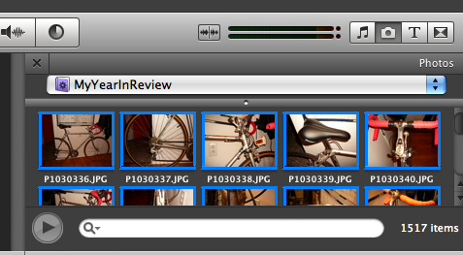
4. Ctrl-Click on one of the photos, choose "Set Duration" and change the duration for all photos to 0.3 seconds (the shortest iMovie will let you)
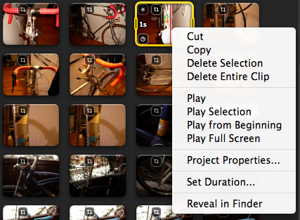
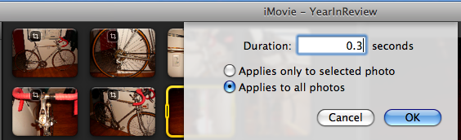

5. Select a song, drag it onto the timeline to play over your show

6. If you have a microphone set up (or built-in) record yourself (in one take) explaining what's happening throughout the year as the photos appear.
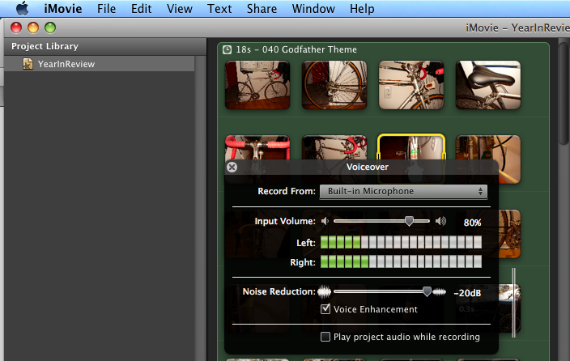

7. Post that sh*t.

Example: http://backinblakk.blogspot.com/2007/08/catch-up-vlog.html

